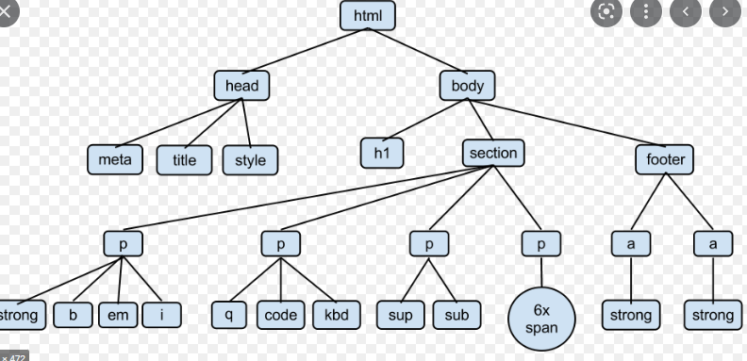

This is the diagram of HTML tree. It first consists of 2 parts, head and body. The root of our element tree is the html element. It is the only element at the top level of the tree.

A path is a sequence of connected elements moving down from a given element away from the root. Each element in a path has to be below the previous one, so section--p--sub and footer--a--strong are paths, but a--footer--a is not, because the first connection, a--footer, is going up instead of down.

**In head there are 3 parts**

Meta - The <meta> tag defines metadata about an HTML document. Metadata is data (information) about data.

Title - The HTML <title> tag is used for indicating the title of the HTML document. The body title is placed between the <head> and the </head> tags.

Style - The <style> tag is used to define style rules at a page-level (i.e. within the document). The style rules inside the <style> element tell a browser how to present the document.

**In body there are 3 parts h1, section and footer.**

1) h1 - The HTML <h1> element is found within the <body> tag. Headings can range from <h1> to <h6>. The most important heading is <h1> and the least important heading is <h6>. The <h1> heading is the first heading in the document.

2) section - The <section> tag defines a section in a document.

3) footer - The <footer> tag defines a footer for a document or section.

A <footer> element typically contains: authorship information, copyright information, contact information, sitemap, back to top links, related documents

In section tag, there are 4 p tags which is known as paragraph tag.

**In first p tag it contains strong, b, em, i**

1) The <strong> tag is used to define text with strong importance.

2) The <b> tag specifies bold text without any extra importance.

3) The <em> tag is used to define emphasized text. The content inside is typically displayed in italic.

4) The <i> tag defines a part of text in an alternate voice or mood. The content inside is typically displayed in italic.

**In second p tag it contains q, code and kbd**

1) The <q> tag defines a short quotation. Browsers normally insert quotation marks around the quotation.

2) The code tag has no specific meaning.

3) The <kbd> tag is used to define keyboard input. The content inside is displayed in the browser's default monospace font.

**In third p tag it contains sup and sub**

1) The <sup> tag defines superscript text. Superscript text appears half a character above the normal line, and is sometimes rendered in a smaller font.

2) The <sub> tag defines subscript text. Subscript text appears half a character below the normal line, and is sometimes rendered in a smaller font. Subscript text can be used for chemical formulas, like H2O.

**In fourth p tag it contains 6x span.**

The <span> HTML element is a generic inline container for phrasing content, which does not inherently represent anything. It can be used to group elements for styling purposes (using the class or id attributes), or because they share attribute values, such as lang. It should be used only when no other semantic element is appropriate. <span> is very much like a <div> element, but <div> is a block-level element whereas a <span> is an inline element.

. **The HTML Document Tree**

Each HTML document can actually be referred to as a document tree. We describe the elements in the tree like we would describe a family tree. There are ancestors, descendants, parents, children and siblings.

It is important to understand the document tree because CSS selectors use the document tree.

A diagram of the above HTML document tree would look like this.

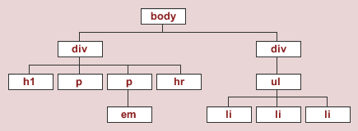

**Ancestor**

An ancestor refers to any element that is connected but further up the document tree - no matter how many levels higher.

In the diagram below, the <body> element is the ancestor of all other elements on the page.

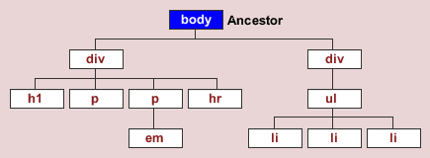

**Descendant**

A descendant refers to any element that is connected but lower down the document tree - no matter how many levels lower.

In the diagram below, all elements that are connected below the <div> element are descendants of that <div>.

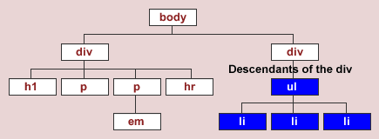

**Parent and Child**

A parent is an element that is directly above and connected to an element in the document tree. In the diagram below, the <div> is a parent to the <ul>.

A child is an element that is directly below and connected to an element in the document tree. In the diagram above, the <ul> is a child to the <div>.

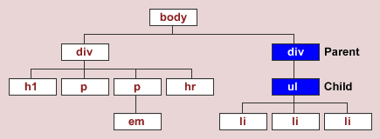

Sibling

A sibling is an element that shares the same parent with another element.

In the diagram below, the <li>'s are siblings as they all share the same parent - the <ul>.

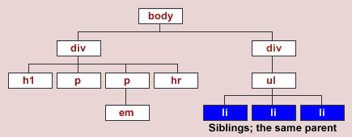

**Hint: These are the notes that you should know about HTML if you want to know the details. To get more understandable, you need to wait next week to get the code with screenshot and slight notes. Please don’t forget to leave a follow to my page to know more about tutorials and notes.**